The Irish Times

Tuesday, July 27, 2010

Dutch master rediscovered
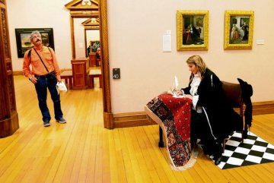 Catherine Ryan poses in front of Man Writing a Letter and Woman Reading a Letter by Dutch 17th century artist Gabriel Metsu at the National Gallery yesterday.
Photograph: Bryan OBrien
JOANNE HUNT
Metsu exhibition for gallery
THE NATIONAL Gallery of Ireland’s autumn exhibition devoted to 17th century Dutch painter Gabriel Metsu will bring together some 40 of the artists most celebrated paintings and drawings from both private and public collections around the world.
Details of the exhibition entitled Gabriel Metsu: Rediscovered Master of the Dutch Golden Age , were announced yesterday.
Metsu, born in Leiden in the Netherlands in 1629 was, during his lifetime, more celebrated than Vermeer.
Fionnuala Croke, keeper and head of collections at the National Gallery said at the time, Vermeer “would have been described as an artist in the manner of Metsu’ ”.
“While Vermeer is interested in light and the magic of the interior, in Metsu, there is more domestic detail giving us a unique window into daily life at the time.”
Dr Adriaan Waiboer, curator of the exhibition said “the seed for this exhibition was the gallerys own Metsu works, Man Writing a Letter and Woman Reading a Letter. ”
These companion pieces, gifted to the gallery in 1987 by Sir Alfred and Lady Beit, having previously been stolen from Russborough House are generally considered to be Metsus best known works.
Dr Waiboer said: “The two pieces are among the gallerys favourites.
“It has taken two years to bring the others to Dublin and this exhibition will be an opportunity for Irish audiences to discover a lesser-known but highly talented artist.”
The exhibition which is organised by the National Gallery in association with the Rijksmuseum, Amsterdam and the National Gallery of Art in Washington also features Metsu works on loan from the Louvre in Paris, the Met in New York and the Prado in Madrid.
It also includes a number of works from private collections rarely seen in public.
The exhibition is running from September 4th to December 5th in the Beit Wing of the National Gallery.
It will be accompanied by a series of lectures.
© 2010 The Irish Times

